Object-Oriented Programming

BS (CS) _Spring_2026

Lab_04 Tasks


Learning Objectives:

- 2D pointers
- Recursion

POINTERS
A pointer is a variable that stores an address of a memory location.

Pointer Declaration and initialization
Pointers is declared as follow.
Type* <variable Name>;

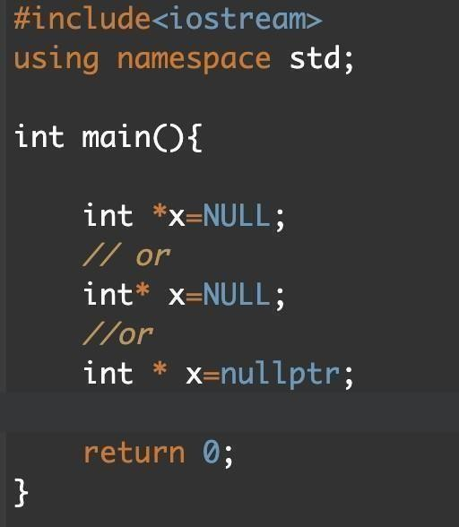

Address-of operator (&)
The ampersand, &, called the address of operator, is a unary operator that returns the address of its operand.

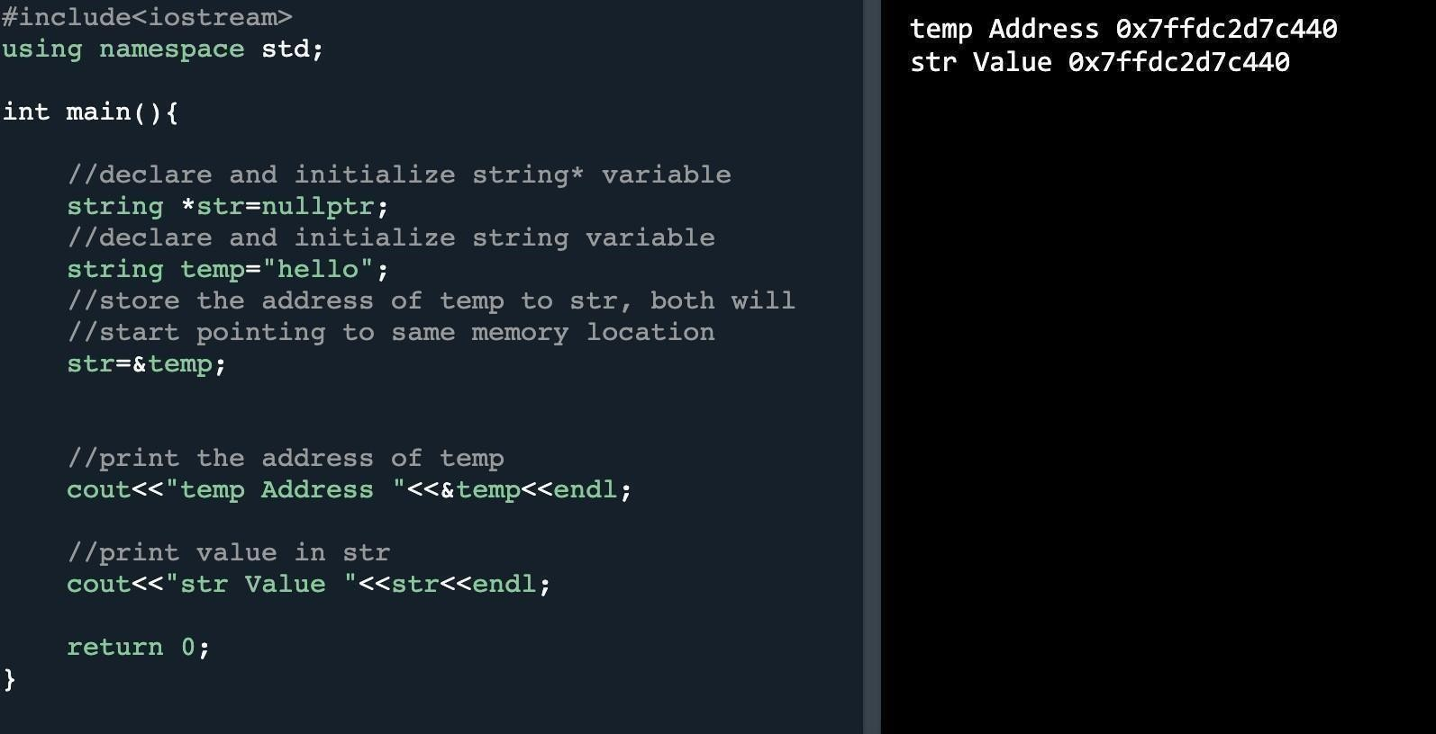

Dereference operator (*)
The unary operator * is the dereferencing operator that returns the value of its operand.

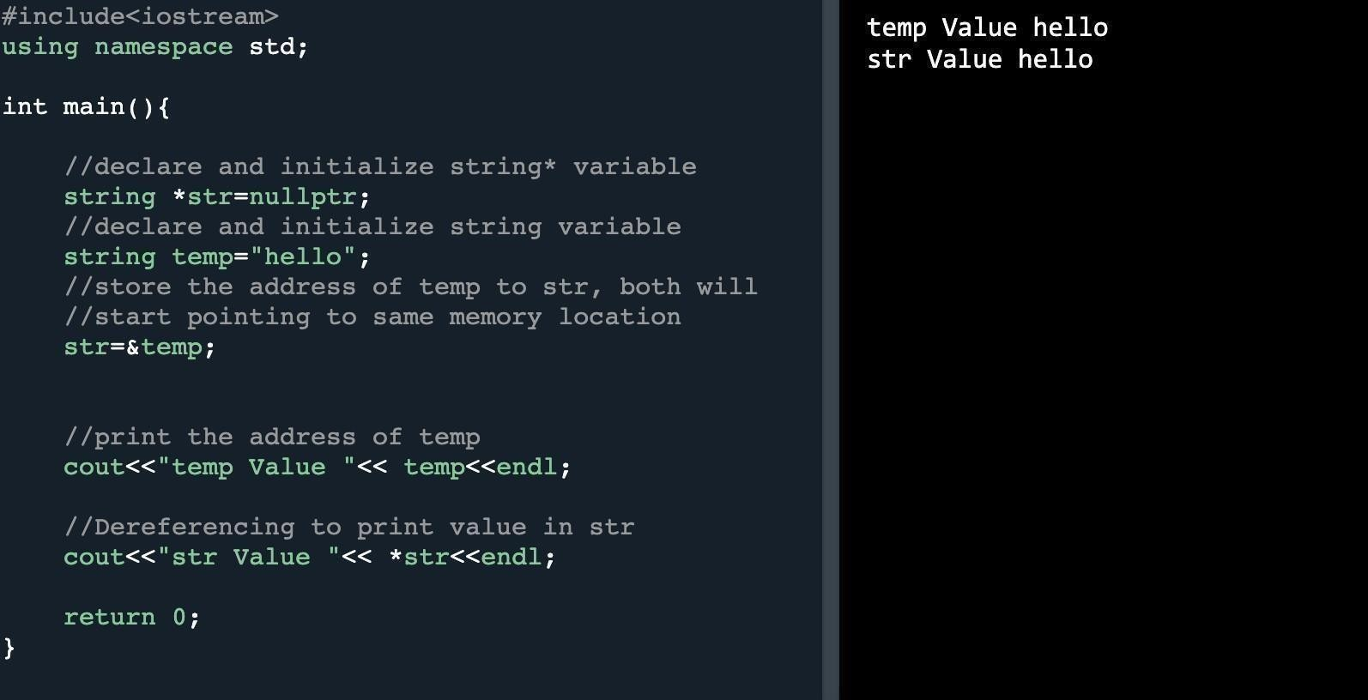

Initializing double pointers
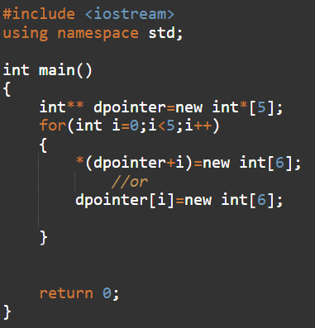

Traversing double pointers
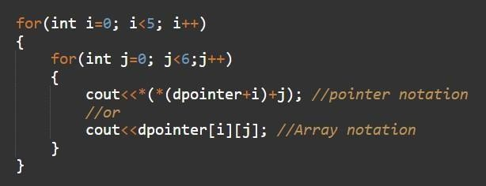

Lab Tasks

Submission Instructions
- Create a separate .h and .cpp file for each class.
- Now create a new folder with name ROLLNO_SEC_LAB04 e.g. i25XXXX_A_LAB04(Also name your cpp and header files like this.)
- Move all of your files (only your coding header and cpp files) to this newly created directory and compress directly it into a .zip file. (No folder)
- Now you have to submit this zipped file on Google Classroom.
- If you don’t follow the above-mentioned submission instruction, you will be marked zero.
- Plagiarism and AI generated code in the Lab Task will result in zero marks in the whole category.

Questions
- You are given a garden represented as a 2D grid of size N x M (N rows, M columns) where each cell in the grid correspond to a pot, which can eithher be intact or broken. Where some pots that are broken cannot hold plants. Broken pots are represented as 0 and intact pots are represented as 1 in the grid (user input).
Your task is to determine how to plant strategically under the following rules:
- You can plant a maximum of one plant per pot.
- No two plants in the same row can be planted in adjacent columns (consecutiveness rule). Means you cannot plant two plants in pots that are next to each other in the same row.
- You cannot plant in broken pots.
Compute the maximum number of plants while representing the rules. Also compute the minimum number of plants needed to cover the garden such as each contiguous segment of intact pots in a row has at least one plant. No additional plants can be added without violating the non-consective rule.
Output should look like this
Enter total number of rows: 3
Enter total number of columns: 5
[ [1, 1, 0, 1, 1],
[1, 0, 1, 1, 0],
[1, 1, 1, 1, 1] ]
Maximum plants: 7
Maximum covering plants: 5
- You are given a matrix of natural numbers of size N x M where each cell represents a chemical sample in a laboratory. Let MAX denote the maximum element of the matrix and MIN denote the minimum element. Any cell containing MAX or MIN is considered unsafe, and an unsafe cell corrodes its entire row and column, making all other cells in the same row and column unsafe as well. Your task is to use dynamic memory allocation with 2D pointers (int**) to create and store the matrix, identify all unsafe cells according to these rules, count the number of remaining safe cells, and display the matrix with unsafe cells marked as X while safe cells retain their original values. The input consists of two integers N and M followed by N lines each containing M integers representing the matrix elements. The output should first display the number of safe cells, followed by the updated matrix with unsafe cells marked.
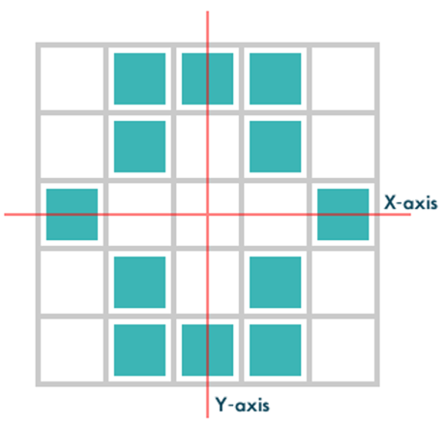
- Roy loves symmetric logos. A logo is represented as a binary matrix of size N × N, where 1 indicates a colored pixel and 0 indicates no color. A logo is considered symmetric if its colored pixels are symmetric about both the X-axis and Y-axis when the center of the logo is aligned with the origin of a Cartesian plane. Your task is to determine whether the logo is symmetric about both axes and print Yes if it is symmetric or No otherwise. The input consists of the integer N followed by N lines of N integers representing the pixels of the logo. The solution must efficiently handle the matrix using dynamic memory, without using static arrays or extra libraries.
For instance: Take a 5x5 matrix as follows
[[0, 1, 1, 1, 0],
[0, 1, 0, 1, 0],
[1, 0, 0, 0, 1],
[0, 1, 0, 1, 0],
[0, 1, 1, 1, 0]]
It is symmetric around x and y axis.

- You are given a chessboard of size N × N and your task is to place N queens on the board such that no two queens attack each other. A queen is represented by 1 and an empty cell by 0. For this simplified version, the rule is: if a queen is placed in a cell, no other queen can be placed in any adjacent cell (including horizontally, vertically, and diagonally). Your task is to use recursion to explore all possible placements and determine a valid configuration of the board. The program should output one valid arrangement of the chessboard showing the positions of all queens. You must implement the solution using recursive function(s), without using iterative placement strategies, and the board can be stored using dynamic memory allocation with 2D pointers (int**).A palindrome is a string that is spelled the same way forward and backward. Some examples of palindromes are radar and madam etc. Write a recursive function that a string and check whether its palindrome or not.
Example:
isPalindrome(”MADAM”,0,5) will return 1.
Prototype of Function: int isPalindrome(string str, int start, int length);

- Create a recursive function to determine whether there exists a subset of a given array of integers that sums up to a specified target value. if yes it returns 1 else 0.
Example: Given the array 3,34,4,12,5,2 and target sum 9, the function should return 1 (since 4 + 5 = 9).

